**Optimal LQR Control**

**Topics Covered**

• Introduction to state-space models.

• State-feedback control.

• Linear Quadratic Regulator (LQR) optimization.

**Prerequisites**

• Filtering laboratory experiment.

• Rotary Pendulum Modeling laboratory experiment.

• Rotary pendulum module is attached to the QUBE-Servo 2.

**1 Background**

Linear Quadratic Regulator (LQR) theory is a technique that is ideally suited for finding the parameters of the pendulum balance controller in the Rotary Pendulum Modeling laboratory experiment. Given that the equations of motion of the system can be described in the form

*x*˙ = *Ax* + *Bu,*

where *A* and *B* are the state and input system matrices, respectively, the LQR algorithm computes a control law *u*

such that the performance criterion or cost function

∫ *∞ T*

*J* = (*xref − x*(*t*))

0

*Q* (*xref − x*(*t*)) + *u*(*t*)*T Ru*(*t*)*dt* (1.1)

is minimized. The design matrices *Q* and *R* hold the penalties on the deviations of state variables from their setpoint and the control actions, respectively. When an element of *Q* is increased, therefore, the cost function increases the penalty associated with any deviations from the desired setpoint of that state variable, and thus the specific control gain will be larger. When the values of the *R* matrix are increased, a larger penalty is applied to the aggressiveness of the control action, and the control gains are uniformly decreased.

In our case the state vector *x* is defined

*x* = [*θ α θ*˙

]*T .* (1.2)

*α*˙

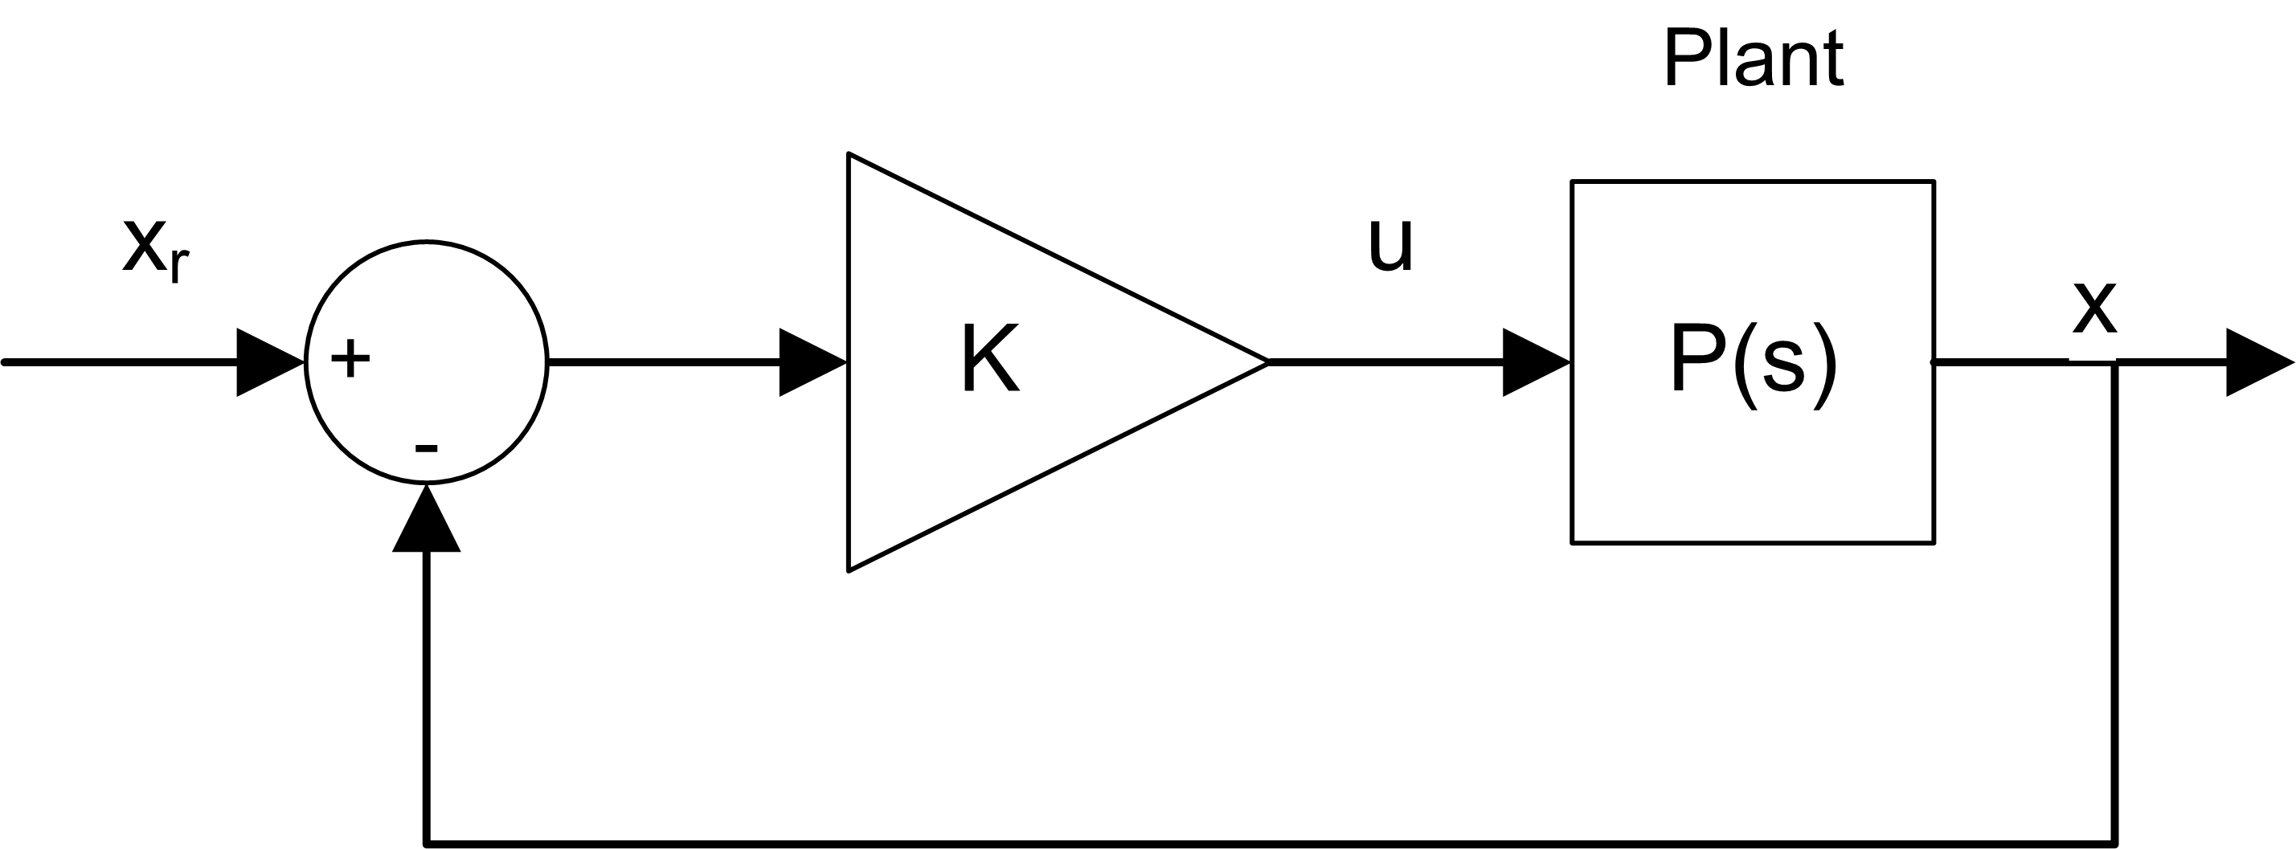

Figure 1.1: Block diagram of balance state-feedback control for rotary pendulum

Since there is only one control variable, *R* is a scalar. The reference signal *xref* is set to [*θ*

*r*

control strategy used to minimize cost function *J* is thus given by

]*T*

0 0 0

, and the

*u* = *K* (*xref − x*) = *kp,θ* (*θr − θ*) *− kp,α α − kd,θ θ*˙ *− kd,α α*˙ *.* (1.3)

This control law is a state-feedback control and is illustrated in Figure 1.1. It is equivalent to the PD control explained in the Rotary Pendulum Modeling laboratory experiment.

**2 In-Lab Exercises**

**2.1 LQR Control Design**

LQR design theory is available through the LඉඊVIEW™ *Control Design & Simulation* module. Given a model of the system in state-space form (with system matrices *A* and *B*) and the weighting matrices *Q* and *R*, the LQR function in the *Control Design* Toolkit automatically minimizes the cost function Equation 1.1 computes the optimal feedback control gain automatically.

In this experiment, the state-space model is already available. In the laboratory, the effect of changing the *Q*

weighting matrix while *R* is fixed to 1 on the cost function *J* will be explored.

1. In the *QUBE-Servo 2* project file, expand the Windows target as well as the *LQR Design* virtual folder. Run the QUBE-Servo 2 ROTPEN State-Space Model.vi shown in Figure 2.1. This loads the QUBE-Servo 2 rotary pendulum state-space model matrices *A, B, C,* and *D* and saves it to the file qube_servo_2_rotpen_model in a folder called Rotary Pen Model.

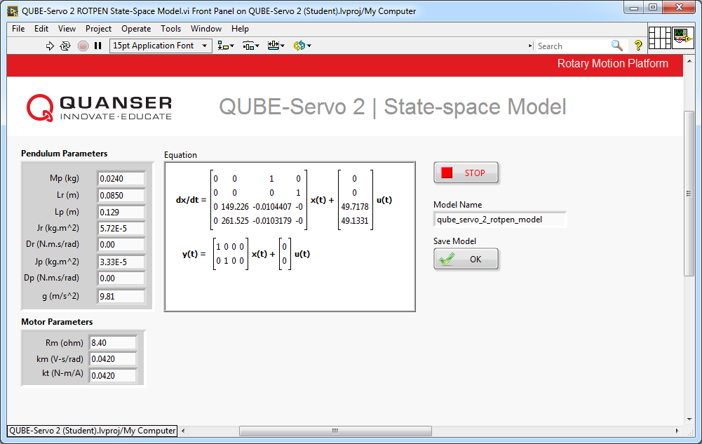

Figure 2.1: VI to generate QUBE-Servo 2 ROTPEN State-Space Model

2. Proceed to design a VI similar to Figure 2.2 to find the open-loop poles of the system. Use Read Model from File to load the model file you just saved (saved in the Rotary Pen Model folder). What do you notice about the location of the open-loop poles? How does that affect the system?

3. Use the CD Read Model from File and CD Linear Quadratic Regular VIs as shown in Figure 2.3 to generate the control gain *K* . Generate *K* using the following weighting matrices:

 

1 0 0 0

 

|  |  |
| --- | --- |
| 1 | 0 |
| 0 | 1 |
| 0 | 0 |

0

0

*Q* = 





0



0



 and *R* = 1*.*





0





1

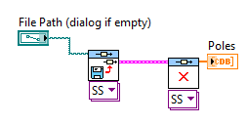

Figure 2.2: Find poles of loaded state-space model

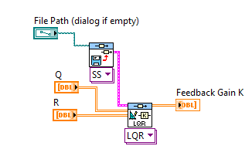

(a) Front Panel

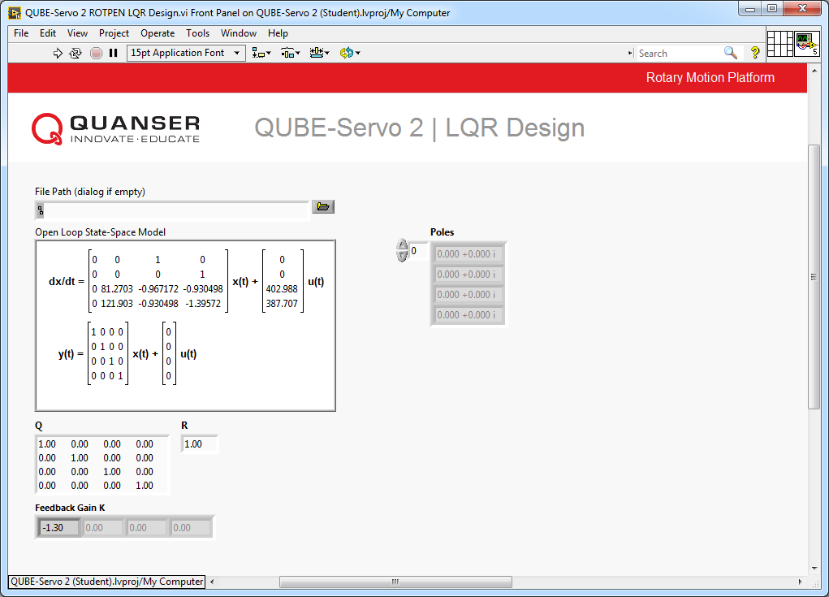

(b) Block Diagram

Figure 2.3: Generate LQR control gain using loaded state-space model

4. Change the LQR weighting matrix to the following and generate a new gain control gain:

 

5 0 0 0

 

|  |  |
| --- | --- |
| 1 | 0 |
| 0 | 1 |
| 0 | 0 |

0

0

*Q* = 





0



0



 and *R* = 1*.*





0





1

Record the gain generated. How does changing *q*11 affect the generated control gain? Based on the description of LQR in the background section, is this what you expected?

**2.2 LQR-Based Balance Control**

Based on the VI developed in the Rotary Pendulum Modeling laboratory experiment, construct a VI similar to that shown in Figure 2.4 that balances the pendulum on the QUBE-Servo 2 Rotary Pendulum system using an adjustable feedback control gain *K* .

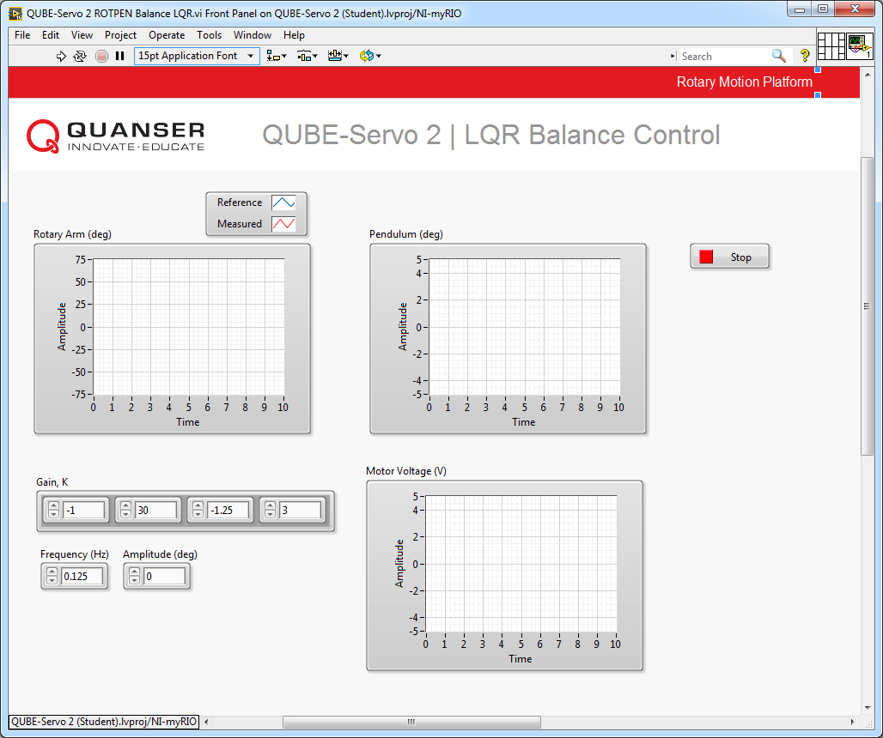

(a) Front Panel

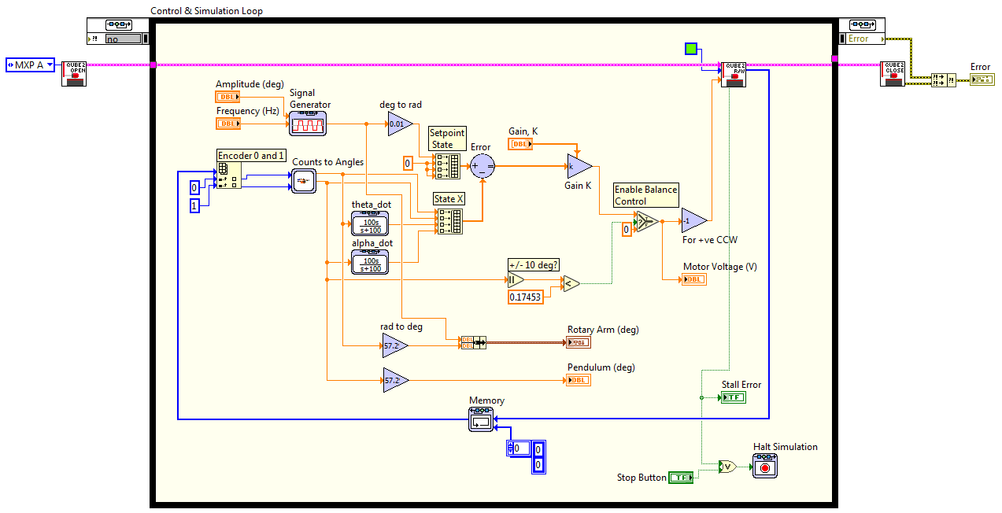

(b) Block Diagram

Figure 2.4: VI to run optimized balance controller

1. Either open QUBE-Servo 2 ROTPEN LQR Design.vi from the LQR Design virtual folder, or use the VI generated in the previous part of this laboratory experiment to generate the control gain *K* based on LQR and the QUBE- Servo 2 model.

2. Using the VI you made in the Rotary Pendulum Modeling laboratory experiment, construct the controller shown in Figure 2.4:

• Using the angles from the Counts to Angles subsystem you designed in the Rotary Pendulum Modeling laboratory experiment (which converts encoder counts to radians), build state *x* given in Equation 1.2. As shown in Figure 2.4 use high-pass filters 100*s*/(*s* + 100) to compute the velocities *θ*˙ and *α*˙ .

• Add the necessary Sum and Gain blocks to implement the state-feedback control given in Equation 1.3. Since the control gain is a vector, make sure the gain block is configured to matrix type multiplication.

• Add the Signal Generator block in order to generate a varying, desired arm angle *θr* . To generate a

*T*

reference state *xr* , make sure you include a Build Array VI to get [*θ*

*r*

]

0 0 0 .

3. Set *K* in the QUBE-Servo 2 ROTPEN Balance LQR.vi to the gain that was generated in Step 3 of the LQR Control Design part of this lab.

4. Set the Signal Generator block to the following:

• Type = Square

5. On the front panel, set the Amplitude (deg) control 0 and the Frequency (Hz) control to 0*.*125.

6. Run the VI.

7. Manually rotate the pendulum in the upright position until the controller engages.

8. Once the pendulum is balanced, set the Amplitude (deg) control to 30 to make the arm angle go between *±*30*◦* .

The scopes should read something similar to Figure 2.5. Attach your response of the rotary arm, pendulum,

and controller voltage.

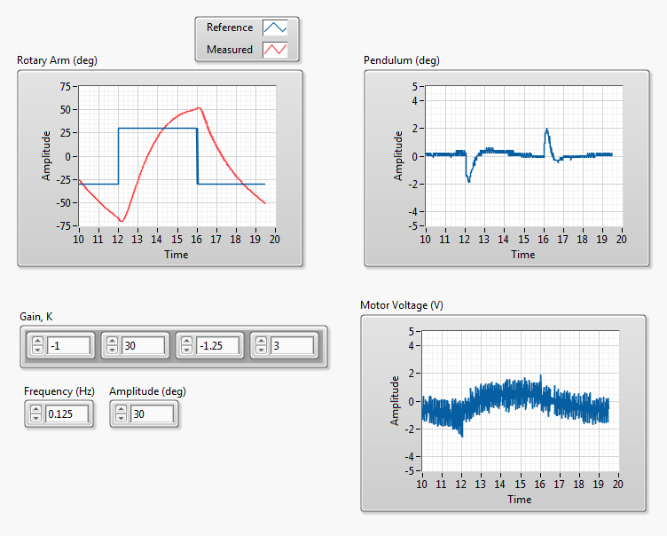

Figure 2.5: QUBE-Servo 2 rotary pendulum response

9. Set *K* to the gain that was generated in the last step of the LQR Control Design part of this lab.

10. Examine and describe the change in the *Rotary Arm (deg)* and *Pendulum (deg)* scopes.

11. Adjust the diagonal elements of *Q* matrix to reduce how much the pendulum angle deflects (i.e. overshoots)

when the arm angle changes. Describe your experimental procedure to find the necessary control gain.

12. List the resulting LQR *Q* matrix and control gain *K* used to yield the desired results. Attach the responses using this new control gain and briefly outline how the response changed.

13. Click on the Stop button to stop the VI.

© 2017 Quanser Inc., All rights reserved.

Quanser Inc.

119 Spy Court

Markham, Ontario

L3R 5H6

Canada

[info@quanser.com](mailto:info@quanser.com)

Phone: 1-905-940-3575

Fax: 1-905-940-3576

Printed in Markham, Ontario.

For more information on the solutions Quanser Inc. offers, please visit the web site at:

[http://www.quanser.com](http://www.quanser.com/)

This document and the software described in it are provided subject to a license agreement. Neither the software nor this document may be used or copied except as specified under the terms of that license agreement. Quanser Inc. grants the following rights: a) The right to reproduce the work, to incorporate the work into one or more collections, and to reproduce the work as incorporated in the collections, b) to create and reproduce adaptations provided reasonable steps are taken to clearly identify the changes that were made to the original work, c) to distribute and publically perform the work including as incorporated in collections, and d) to distribute and publicly perform adaptations. The above rights may be exercised in all media and formats whether now known or hereafter devised. These rights are granted subject to and limited by the following restrictions: a) You may not exercise any of the rights granted to You in above in any manner that is primarily intended for or directed toward commercial advantage or private monetary compensation, and b) You must keep intact all copyright notices for the Work and provide the name Quanser Inc. for attribution. These restrictions may not be waved without express prior written permission of Quanser Inc.